|  |  |  |  |  |  |
| --- | --- | --- | --- | --- | --- |
| **CSC221: DATA STRUCTURES & ALGORITHMS**  **BSCS 3*B***   |  |  |  |  | | --- | --- | --- | --- | | |  | | --- | | LAB | | **05** | | An array based implementation of STACK with the help of algorithm for following functions   * Push() * Pop() * Peek() * Display Stack() |   Bahria_Logo  **Submitted By:**   * Ahsan Ghaffar * Reg: 48411 * BS(CS)\_3B   **Submitted to:**   * Miss Ambreen Akram(AA)   **Submission Date:**  [19/03/2018]  **DEPARTMENT OF COMPUTER SCIENCE**  **BAHRIA UNIVERSITY, KARACHI CAMPUS**  **LAB TASKS:** |  |
| |  |  |  | | --- | --- | --- | | 1 | Write a program as follows for STACK   |  | | --- | | ----------------------Array based implementation of STACK-----------------------------------   1. Push an element on stack 2. Pop an element from stack 3. Display all 4. Top element 5. Exit   -------------------------------------------------------------------------------------------------------------  Please Enter Your Choice: | |   **SORCECODE:**  #include <iostream>  #include <cstdlib>  using namespace std;  int const siz = 6;  int stack[siz], top = -1;  bool isFull()  {  bool flag = false;  if (top == siz - 1)  {  return !flag;  }  else  {  return flag;  }  }  bool isEmpty()  {  bool flag = false;  if (top == - 1)  {  return !flag;  }  else  {  return flag;  }  }  void push(int value)  {  if (isFull())  {  cout << "\nStack Overflow" << endl;  }  else  {  cout << "\nValue has been inserted:" << endl;  top++;  stack[top] = value;  }  }  void pop()  {  if (isEmpty())  {  cout << "\nStack Underflow" << endl;  }  else  {  cout << "\nValue Has Been Deleted: " << endl;  stack[top] = NULL;  top--;  }  }  void peek()  {  cout << "The Peek Value is: " << stack[top] << endl;  }  void display()  {  if (isEmpty())  {  cout << "\nStack Underflow" << endl;  }  else  {  cout << "\nThe Stack Values are :" << endl;  for (int i = 0; i <= top; i++)  {  cout << stack[i] << endl;  }  }  }  int main()  {  int choice, value;  char ch;  do  {  cout << "\n1.push\n2.pop\n3.peek\n4.display" << endl;  cout << "Enter your choice:" << endl;  cin >> choice;  if (choice == 1)  {  cout << "\nEnter any integer value for insertion:" << endl;  cin >> value;  push(value);  }  else if (choice == 2)  {  pop();  }  else if (choice == 3)  {  peek();  }  else if (choice == 4)  {  display();  }    cout << "\nEnter y to continue and n to exit: ";  cin >> ch;  } while (ch != 'n');  system("pause");  }   |  |  | | --- | --- | | 2 | Test the program using the following procedure: STACK of size N=6   1. Call PUSH(5) 2. Call PUSH(2) 3. Call PUSH(3) 4. Call POP() 5. Call PUSH(6) 6. Call PUSH(9) 7. Call PUSH(3) 8. Call DISPLAY() 9. Call TOP() | | |

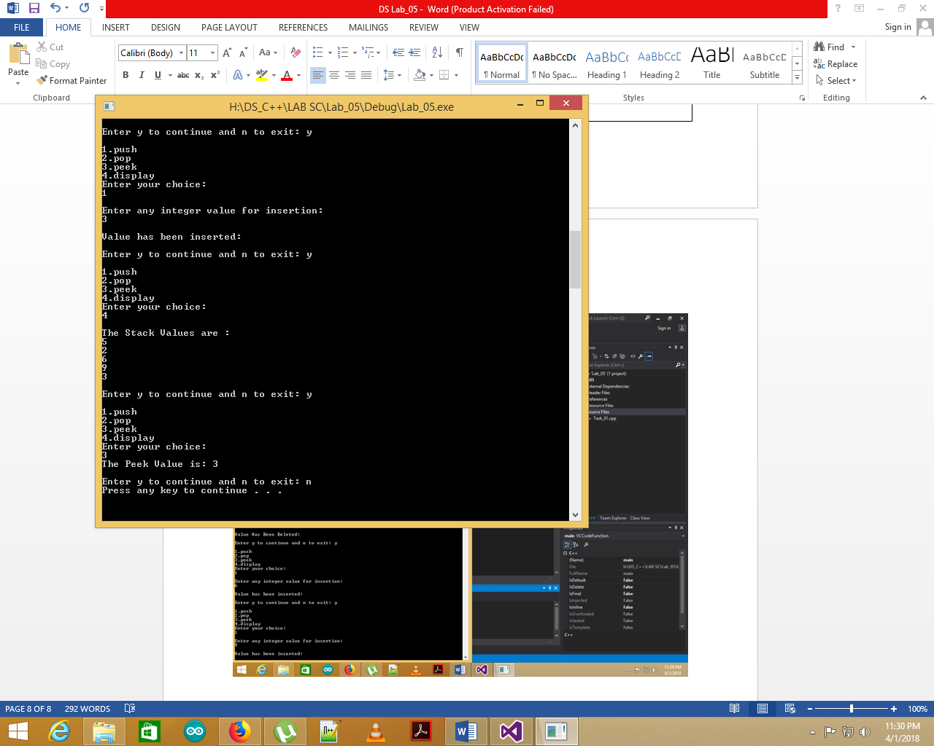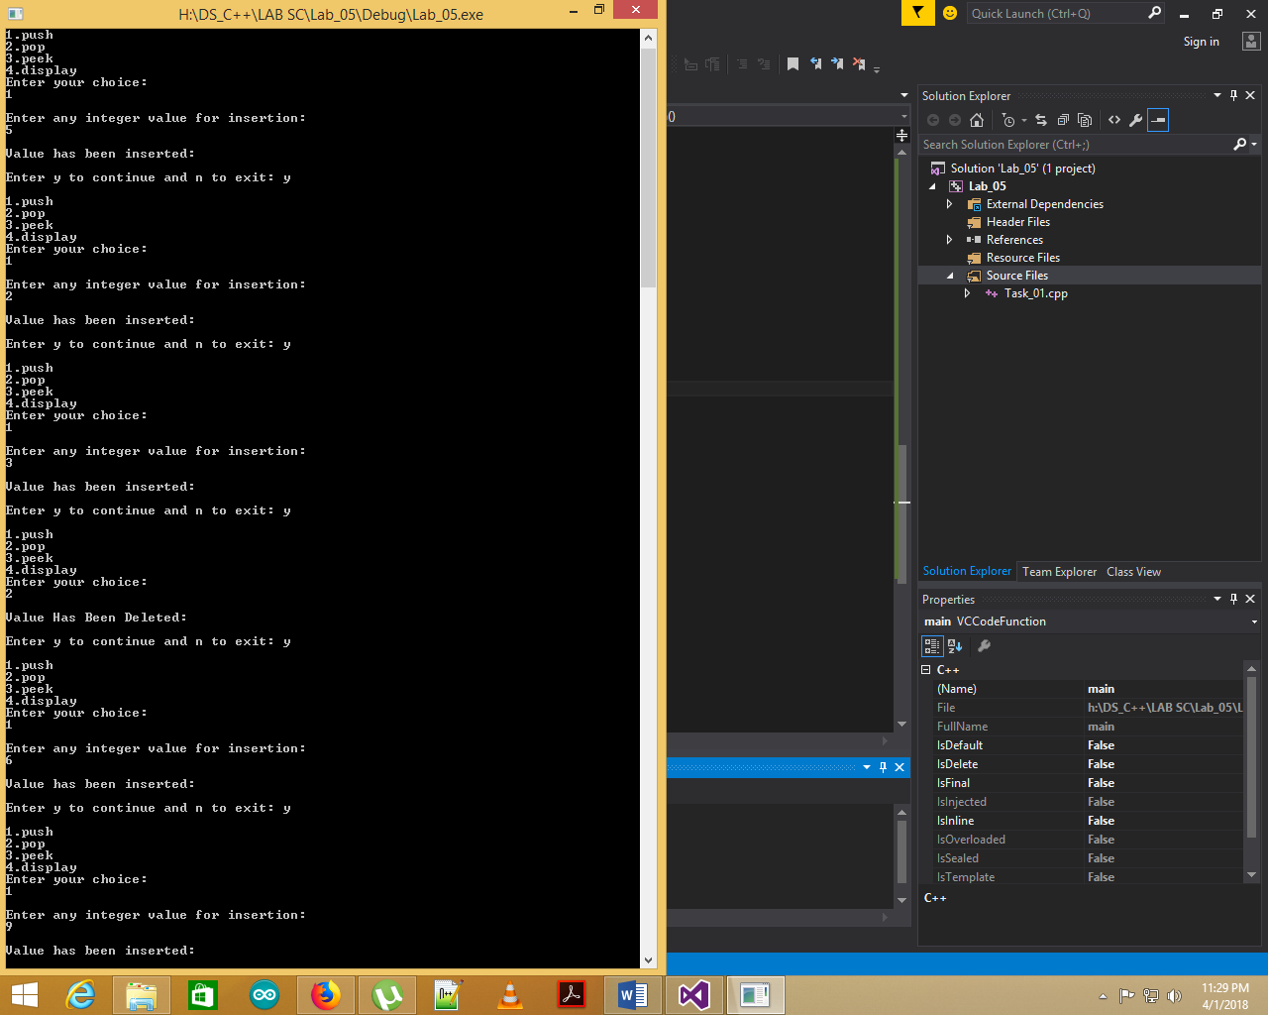**SCREENSHOT:**